CS 3305-01 Web Programming 2

Instructor: Professor Jim Casale

Name: Anonymos

Programming Assignment Unit 6

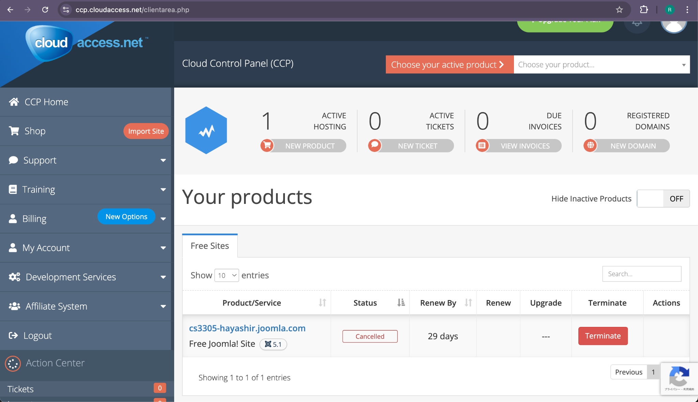

Figure 1 Client Area Screenshot

This screenshot is from the Joomla client area, showing the URL of my Joomla site and the details of the free hosting service provided by CloudAccess.net.

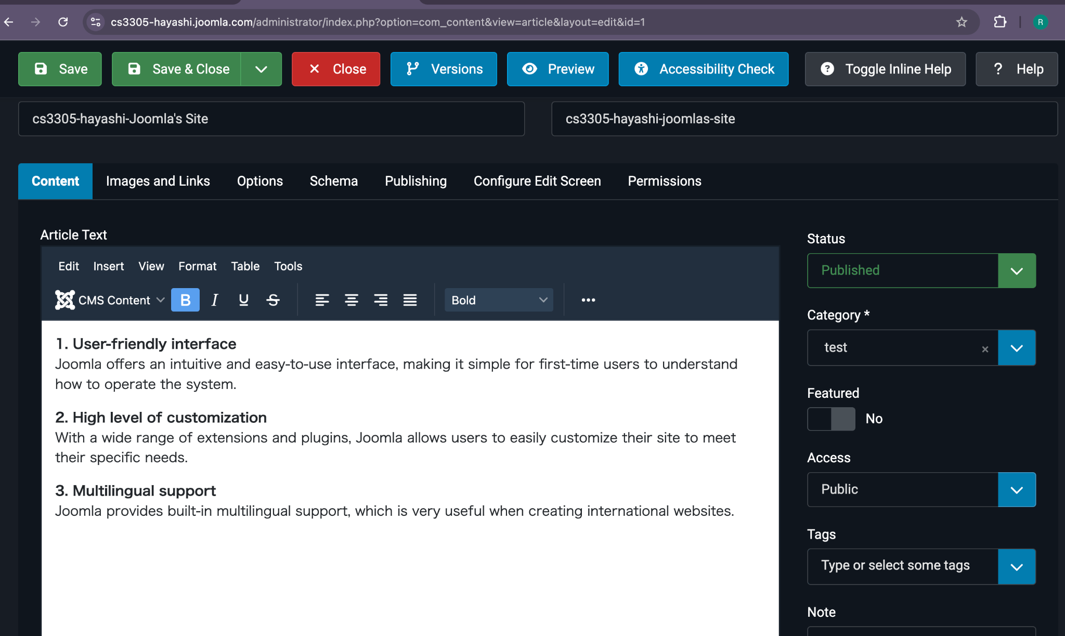

Figure 2 Administrator Panel Screenshot

This screenshot displays the Joomla administrator panel where I have edited the "Getting Started" article, updated the title, and included the list of three things I appreciate about Joomla.

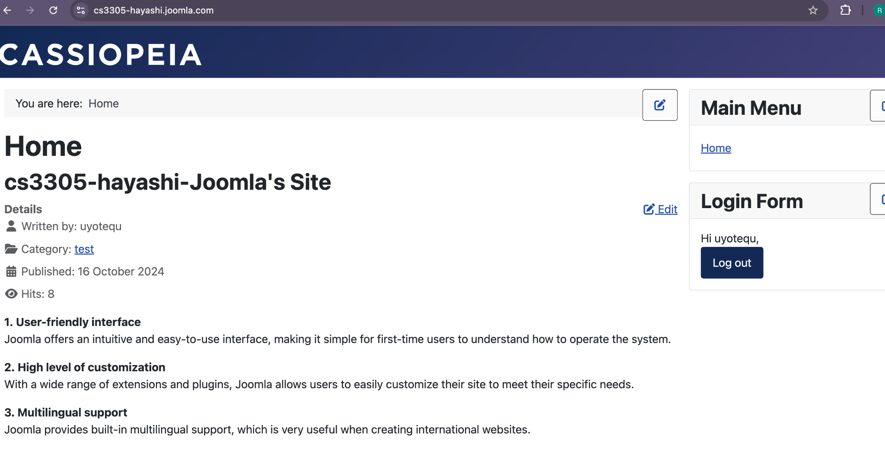

Figure 3 Joomla Site Screenshot

This screenshot shows the homepage of my Joomla site titled "cs3305-hayashi-Joomla's Site", reflecting the updated article title and the three features I like about Joomla so far.

Word Count: 97

References

1. CloudAccess.net. (n.d.). *Cloud control panel (CCP).* Retrieved from https://ccp.cloudaccess.net/
2. Joomla. (n.d.). *Joomla! Launch: Free Joomla! demo hosting.* Retrieved from https://launch.joomla.org/